# Lab:160 - Build Your DB Server and Interact With Your DB Using an App

**Create Security group:**

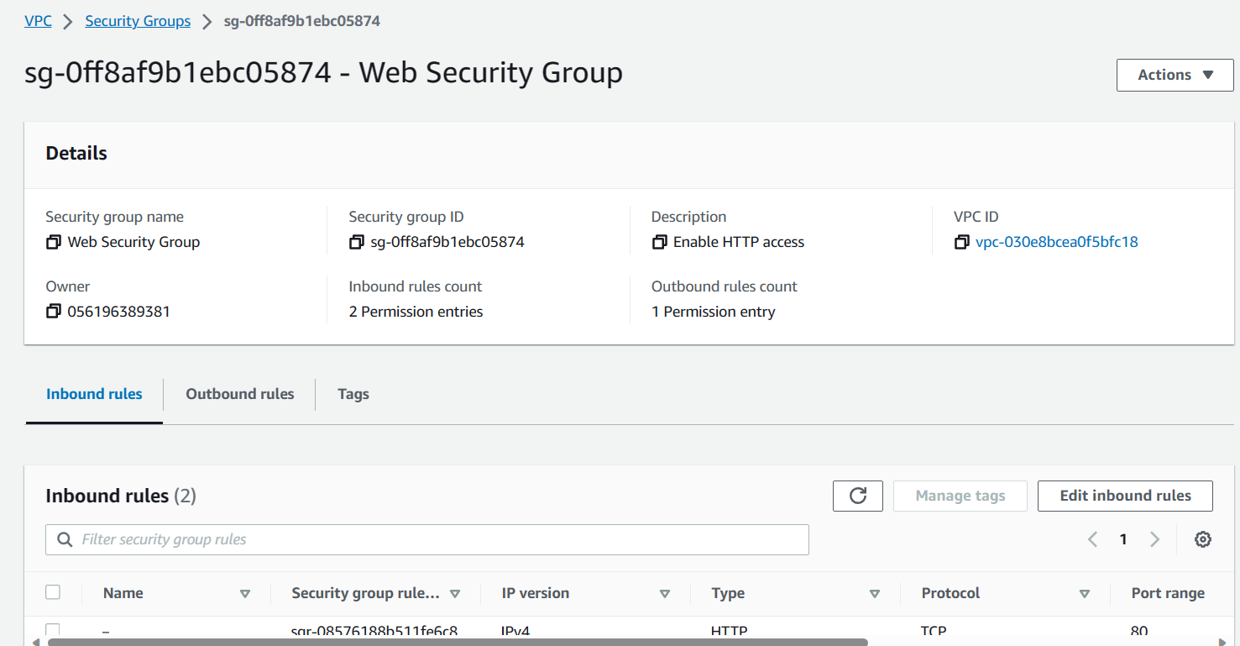

**Create database Subnet Group:**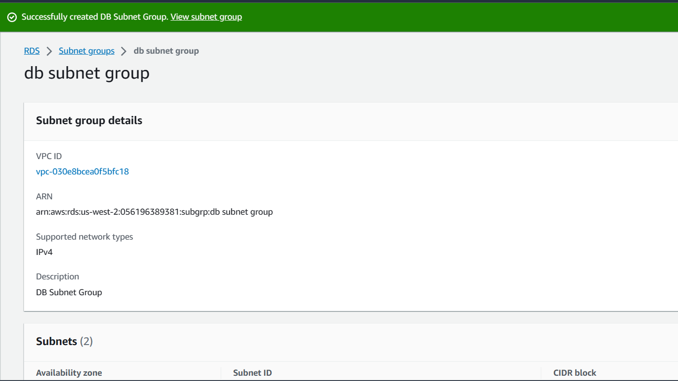

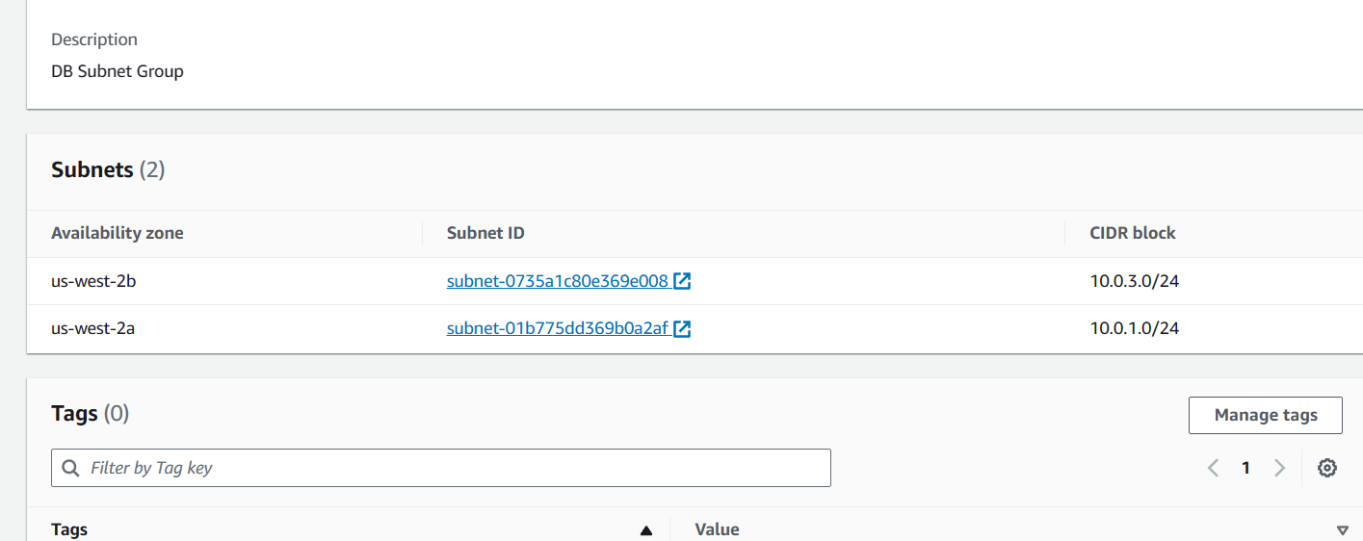

**Create Database:**

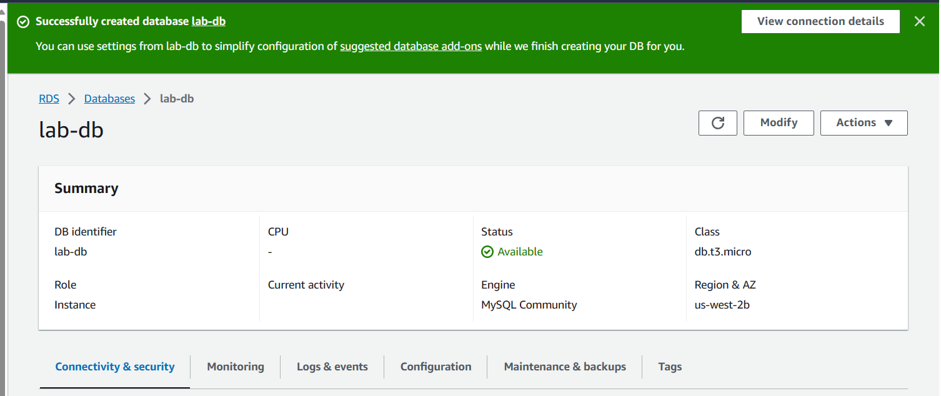

Copy theWeb Server IP address **by selecting** i AWS Details and open in a new web browser.

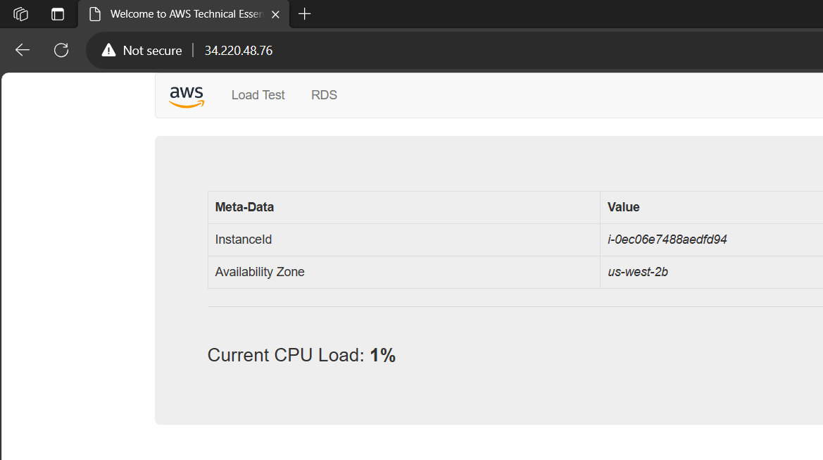

**Click on RDS, fill the below details and submit.**

